NEWSLETTER - SUNDAY 15 JULY 2018

PASTOR’S POINTS
Uncomfortable is the name of the series that we are working our way through at the moment.
I wonder just how comfortable we are as we come to worship on Sunday evening.
I wonder how comfortable we are sharing our faith to others.

Unfortunately we were unable to get enough support for the Craft at the Markets or to support a Families Bible Study in the park.
Other ways of engaging with the community we serve will continue to be explored.

Matthew reminds us of what we are called to do in our Christian life.
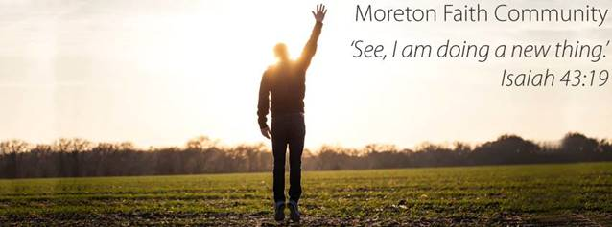
“Go and make disciples” it’s not an easy task, and it is not comfortable but it is what we are called to do.
Watch this space to see how you can join us as we seek to make Disciples.

Blessings
Neil

PRESIDENT-ELECT - REV SHARON HOLLIS
Rev. Sharon Hollis will be the first ordained woman to lead the Uniting Church after being named as President-elect at the 15th Assembly.
Rev. Hollis, who is Moderator of the Synod of Victoria and Tasmania, will be the third woman to occupy the President's role.

“I am humbled and I am grateful,” Rev. Hollis said after the announcement was met with a standing ovation in the Box Hill Town Hall.

St Paul’s Stafford, 242 Webster Road Stafford Saturday 21 July 2018 (9.30 am – 12.30 pm)
RSVP by Wednesday 18 July 2018 to Mavis Nielsen Ph: 3356 9465
Chermside Kedron Community Church, 590 Gympie Rd, Chermside Monday 13th August (7.00 pm – 10.00 pm)
For more information and online registration click here.
Morayfield Uniting Church, 12-16 Weier Rd, Morayfield Sunday 16th September (10.00 am – 1.00 pm)
For more information and online registration click here

Orientation to Mental Health Pastoral Care
Workshop: Wednesday 25th July 2018
Chermside Kedron Community Church
Cnr Rode Rd & Gympie Rd, Chermside

Learning for Living Courses

2018 Learning for Living Courses Semester 2
“New Testament” commence 26 July 2018
Registrations are open!
For more information and registration click here

Synod Sexual Misconduct Complaints Committee
Lay Committee Member required:
The Synod is requesting that Presbytery nominate both a Ministry Agent and a lay person to assist respondents and complainants as they engage in the SSMCC process. Training will be offered for all involved and will be held at the UC Centre on 4th August. Further details will be provided closer to the date. Costs, including travel and accommodation (if required) will be met by the Synod Office.
Information Sheet - SSMCC

WOMEN’S MINISTRY - contact Lynn Cameron 0414295002
Monday - 7p.m.
16 July - Christmas Craft at Julie Miller’s
23 & 30 July - Bible Study at Lynn Cameron’s

UNITING WOMEN 2018
BRISBANE 27-30 SEPTEMBER - https://unitingwomen.org.au/

PINE RIVER’S SHOW - AUGUST 3-5 - PLEASE LET PAUL KNOW IF YOU CAN WORK ON THE GATE

FIFTH ANNIVERSARY SERVICE
Please join us for this special celebration on July 29 at 5.00p.m. Pizza and cake are being organised for dinner so we need to know if you are coming. Contact Chris 0416140600 by July 22.

ASSEMBLY UPDATE
The 15th National Assembly of the UCA concluded on the 14th July.
It has been a very exciting and also a troubling time for many.

Starting last Sunday, Assembly has resolved significant items including:
• affirming that the First Peoples of Australia, the Aboriginal and Islander Peoples, are sovereign peoples in this land;
• the installation of Dr Deidre Palmer as President and election of Rev Sharon Hollis as President-Elect; and
• adopting statements on family and domestic violence and disability access.
• adopting the statement ‘For the whole of creation’ regarding our ongoing
responsibility to walk gently on this earth.

Late last night the Assembly came to a resolution around the issue of Same Gender Marriage.
The Assembly resolved after a very long process where very diverse views were held, to honour the diversity of Christian belief among our members, to hold two equal and distinct statements of belief on marriage. This decision will allow ministers and celebrants in the Uniting Church the freedom to conduct or to refuse to conduct same-gender marriages.

The existing statement of belief that “marriage for Christians is the freely given consent and commitment in public and before God of a man and a woman to live together for life” has been retained.
And a new additional statement of belief has been adopted, which reads “marriage for Christians is the freely given consent and commitment in public and before God of two people to live together for life.”
What this means is that ministers who, in good conscience, are willing to conduct same-gender marriages are able to do so, and does not compromise the rights of those ministers who, in good conscience, cannot conduct same-gender marriages.

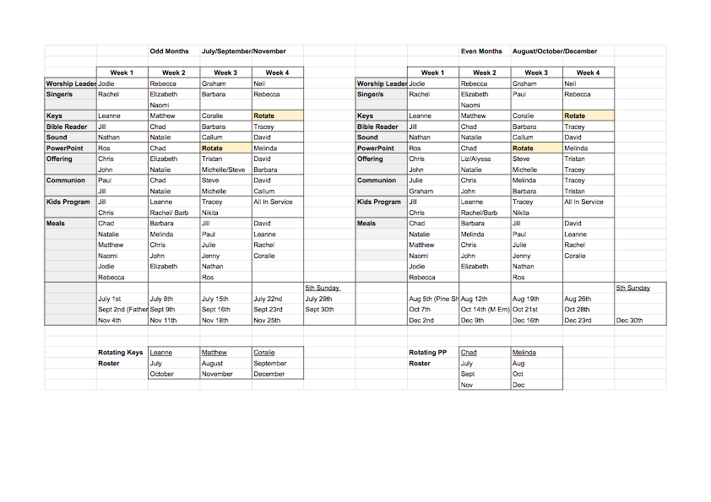
On Wednesday July 25th, Moreton Rivers Presbytery will be holding an information night including the Queensland Synod Moderator, Rev. David Baker and Assembly attendees. This invitation is open to members of your community to hear more about the discernment process that led to the adoption of Proposal 64 ‘Marriage and same-gender relationships’. This night commences at 7pm with a venue to be confirmed next week.

If you have any questions about this please speak to Neil

ROSTER FOR JULY - DECEMBER 2018
PLEASE NOTE: 15 JULY AND 22 JULY FOOD GROUPS ARE SWAPPING.

